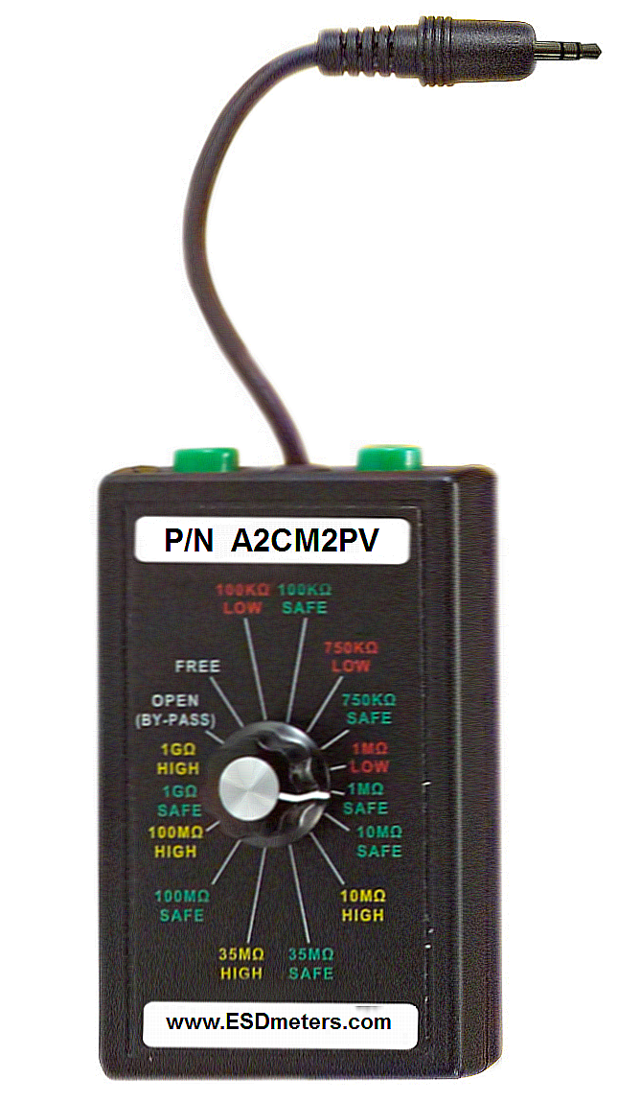

P/N A2CM2PV
Instruction Manual
Periodic Verification Unit
Wrist Strap Verification Procedure
1. Before you begin, the A2CM2 / A2CMS unit should be set up according to manufacturers settings found in the A2CM2 / A2CMS Owner’s Manual.
2. Plug the Periodic Verification Unit (PVU) main lead (Male Phono Plug) to the OP1 remote of the workstation monitor.
3. To verify that the A2CM2 / A2CMS’s resistance limits, turn the dial of the PVU to each designated resistance and record the A2CM2 / A2CMS reaction.
4. The A2CM2 / A2CMS will react in one of the following ways: LED will turn RED + Alarm (RA), YELLOW + Alarm (YA)or GREEN + No Alarm (GN).
5. Repeat procedure with PVU plugged into OP2.
6. Compare your results to that of the Workstation Verification table shown below.
7. The monitor is in working order when the
A2CM2 / A2CMS reaction results match with that
of the table.

If the monitor did not pass as per the test procedure call Bokar International at: 570-842-2812 or Master Distributor
Bomir Inc. at: 570-842-4725 (e-mail bomir@bomir.com)
Resistance Setting | Result | Date | Date | Date | Date | Date
100m High | RA
10 Safe | YA
10 High | YA
100 | YA
1K | YA
10K | YA
100K | YA
1.8 Low | YA
1.8 Safe | YA
3.5 Safe | G
3.5 High | G
10M Safe | G
10M High | G
35M Safe | G
35M High | RA
100M Safe | RA
Wrist Strap Verification Results
Record your results and the date of procedure below.

RA= LED: Red + Alarm
YA = LED: Yellow + Alarm
G= LED; Green

Work Station Verification Procedure
- Before you begin, the A2CM2 / A2CMS unit should be set up according to manufacturers settings found in the
A2CM2 / A2CMS Owner’s Manual.
2. Plug the two test lead in the green input on the top of the Periodic Verification Unit (PVU) .
3. Attach the alligator clips to the ends of the test leads.
4. Detach the A2CM2 / A2CMS from the mat, and clip the alligator clip to the stud on the underside of the head of the cable.
5. Attach the other test lead to the snap on the mat.
6. To verify that the A2CM2 / A2CMS’s resistance limits, turn the dial of the PVU to each designated resistance and record the A2CM2 / A2CMS reaction.
7. The A2CM2 / A2CMS will react in one of the following ways: LED will turn RED + Alarm (RA), YELLOW + Alarm (YA)or GREEN + No Alarm (GN).
8. Repeat procedure with the 2nd work surface if connected.
9. Compare your results to that of the Work station Verification table .
10. The monitor is in working order when the A2CM2 / A2CMS reaction results match with that of the table on the left.

If the monitor did not pass as per the test procedure call
Bokar International at (570 842-2812 or Master Distributor
Bomir Inc. at: 570-842-4725 (e-mail bomir@bomir.com)

